**Step 1: Create a Resource Group**

1. Go to the Azure Portal.
2. Search for and select "Resource groups".
3. Click on "Create".
4. Fill in the details:
   * **Resource group name**: RG-1
   * **Region**: Select "West US"
5. Click "Review + Create" and then "Create".

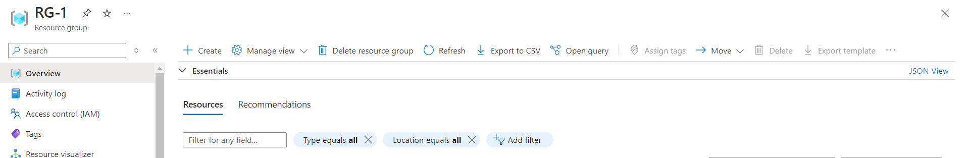

**Step 2: Create a Public IP Address for the Load Balancer**

1. Go to the Azure Portal.
2. Search for and select "Public IP addresses".
3. Click on "Create".
4. Fill in the details:
   * **Name**: MyPublicIP
   * **SKU**: Standard
5. Click "Review + Create" and then "Create".

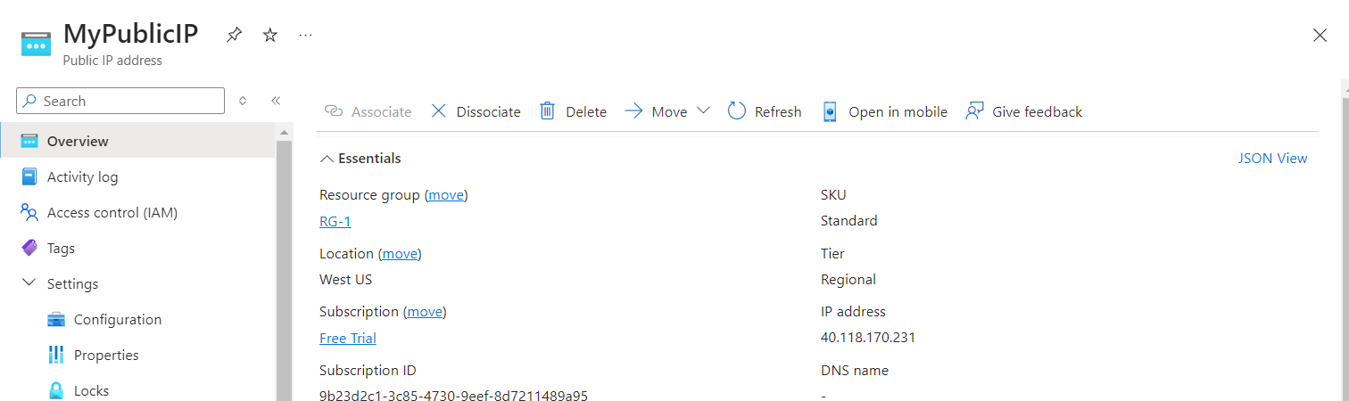

**Step 3: Deploy VM1**

1. Go to the Azure Portal.
2. Search for and select "Virtual machines".
3. Click on "Add" and select "Virtual machine".
4. Fill in the details:
   * **VM name**: VM1
   * **Region**: RG-1
   * **Image**: Ubuntu LTS
   * **Admin username**: azureuser
   * **Authentication type**: SSH public key
5. Click on "Review + Create" and then "Create".
6. After VM1 is created, navigate to the "VM1" blade, select "Run command", and then "RunShellScript". Enter the command to install Apache2:

**sudo apt update && sudo apt install -y apache2**

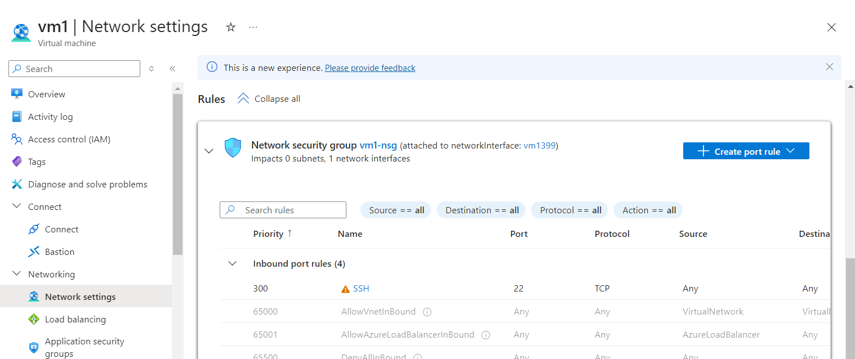

**Step 4: Deploy VM2**

1. Go to the Azure Portal.
2. Search for and select "Virtual machines".
3. Click on "Add" and select "Virtual machine".
4. Fill in the details:
   * **VM name**: VM2
   * **Region**: RG-1
   * **Image**: Ubuntu LTS
   * **Admin username**: azureuser
   * **Authentication type**: SSH public key
5. Click on "Review + Create" and then "Create".
6. After VM2 is created, navigate to the "VM2" blade, select "Run command", and then "RunShellScript". Enter the command to install Apache2:

**sudo apt update && sudo apt install -y apache2**

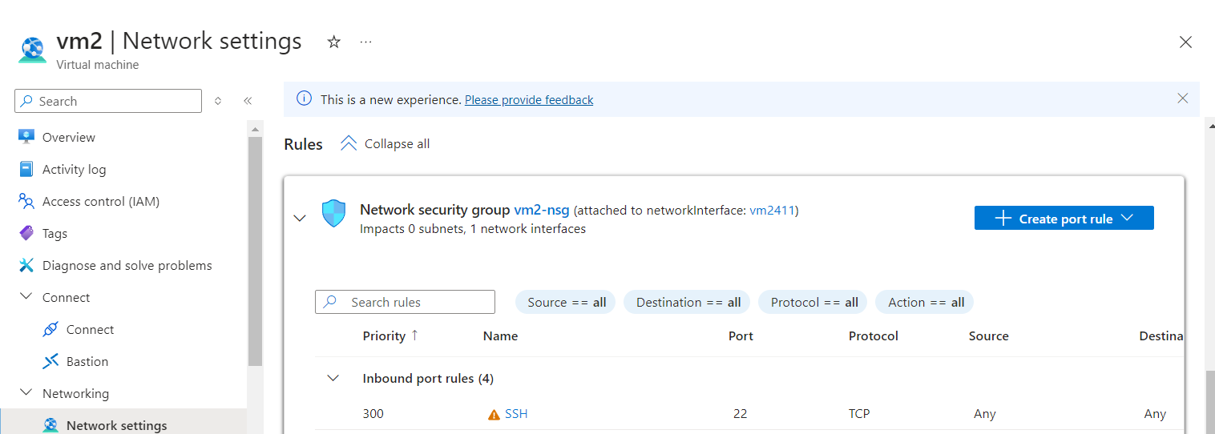

**We do not require to allow port 80 in NSG because we are using App Gateway. It will not be accessible directly.**

**Step 5: Update index.html on VM1**

1. SSH into VM1:

**ssh azureuser@<VM1_Public_IP>**

1. Change the index.html file:

**echo "This is VM1" | sudo tee /var/www/html/vm1/index.html**



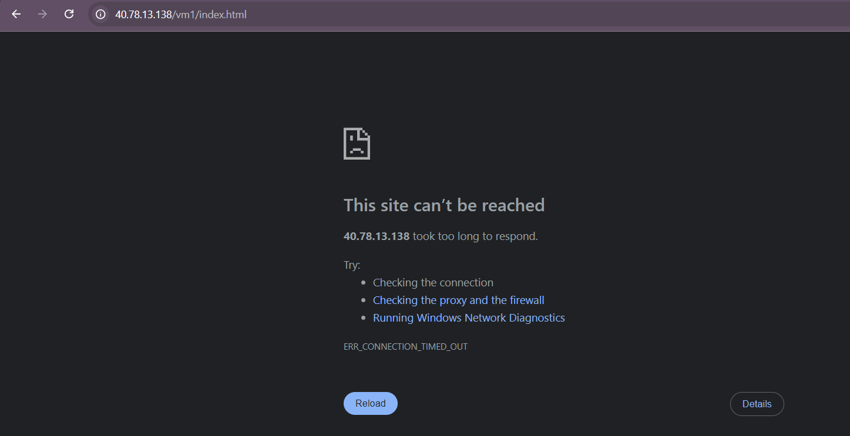

**Step 6: Update index.html on VM2**

**Using Azure CLI:**

1. SSH into VM2:

**ssh azureuser@<VM2_Public_IP>**

1. Change the index.html file:

**echo "This is VM2" | sudo tee /var/www/html/vm2/index.html**



**Step 7: Locate Public IPs**:

* + Inside the resource group, find your two VMs (myVM1 and myVM2).
  + For each VM, click on the **Networking** section on the left menu.
  + Under **Public IP addresses**, click on the **Public IP** resource linked to each VM.

**Step 8: Configure DNS Settings**

1. **Go to the Public IP Configuration**:
   * Once you're on the Public IP address page, look for the **Configuration** option under the **Settings** section in the left menu.
2. **Set the DNS Name Label**:
   * In the **Configuration** page, you'll find a section for **DNS name label**.
   * Enter a unique DNS name for each VM:
     + For VM1, you might use something like **vm1-mydns**(which would create the DNS name **vm1-mydns.westus.cloudapp.azure.com**).

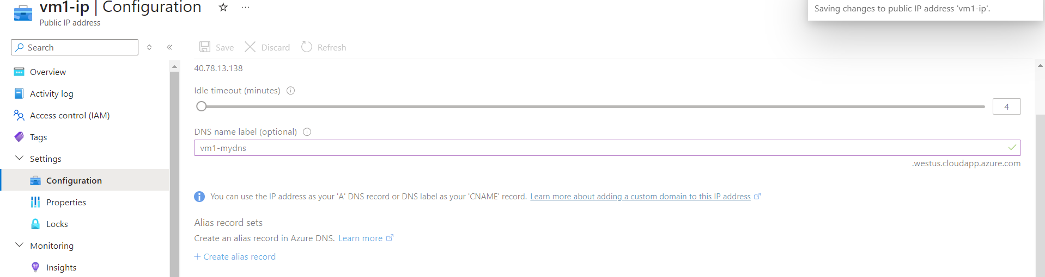

* + - For VM2, you might use **vm2-mydns** (which would create the DNS name **vm2-mydns.westus.cloudapp.azure.com**).

1. **Save the Configuration**:
   * Click on the **Save** button at the top to apply the DNS name settings.

**Step 9: Verify the DNS Configuration**

1. **Check the Public DNS Names**:
   * After saving, navigate back to the Public IP address overview page.
   * You should see the new DNS name under **DNS Name**.

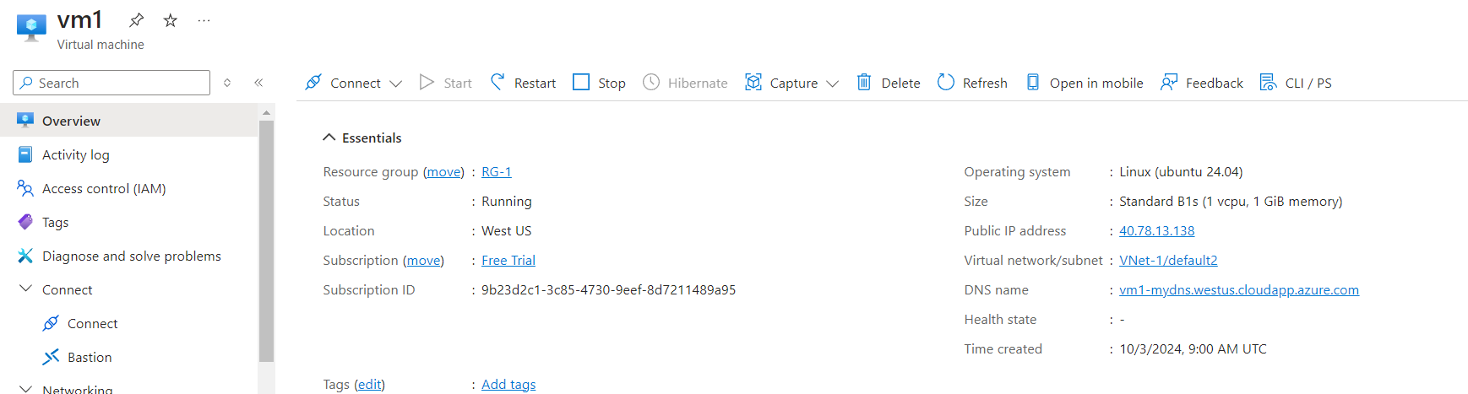

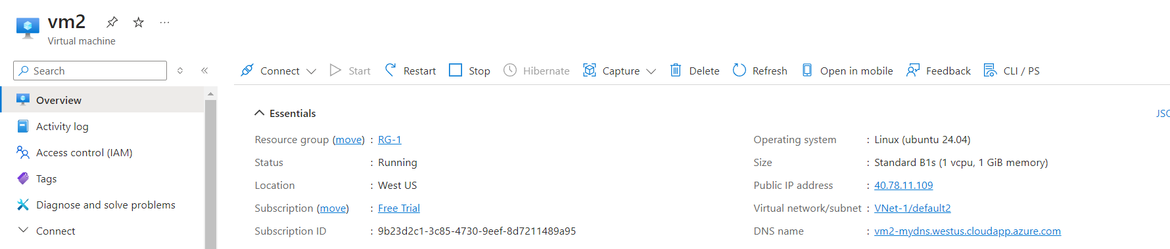

1. **Test the DNS Configuration**:
   * Open a web browser and enter the following URLs:
     + For myVM1: **vm1-mydns.westus.cloudapp.azure.com**

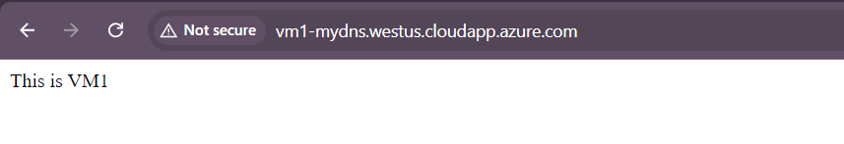

* + - For myVM2: **vm2-mydns.westus.cloudapp.azure.com**

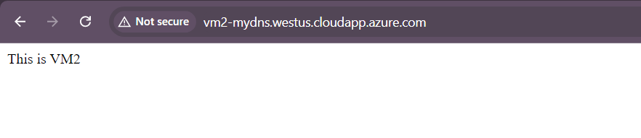

**Step10: Set Up Azure Traffic Manager**

1. **Create a Traffic Manager Profile**:
   * In the Azure Portal, search for **Traffic Manager profiles** and click **Create**.
   * Fill in the required details:
     + **Name**: Give your Traffic Manager profile a name (e.g., TrafficManagerProfile199578).
     + **Routing Method**: Select **Geographic** for geographic load balancing.
     + **Resource Group**: Choose the same resource group as your VMs or create a new one.
     + **Resource Group**: Select the desired location.
   * Click **Review + Create**, then click **Create**.
2. **Add Endpoints to the Traffic Manager**:
   * After creating the Traffic Manager profile, navigate to it.
   * Click on **Endpoints** > **Add**.
   * For the first endpoint (VM1):
     + **Type**: Select **External endpoint**.
     + **Name**: Enter a name (india).
     + **URL**: Enter the public IP address
     + **Region** as Asia and country as **india**
     + Click **Add**.

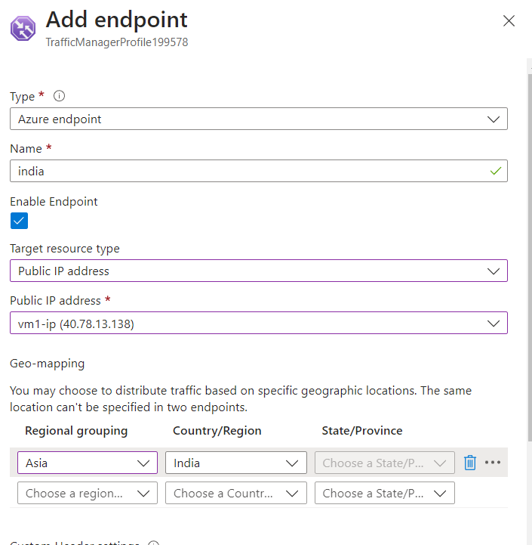

* + Repeat the above steps to add VM2:
    - **Type**: Select **External endpoint**.
    - **Name**: Enter a name US.
    - **URL**: Enter the public IP address
    - **Region** as All World
    - Click **Add**.

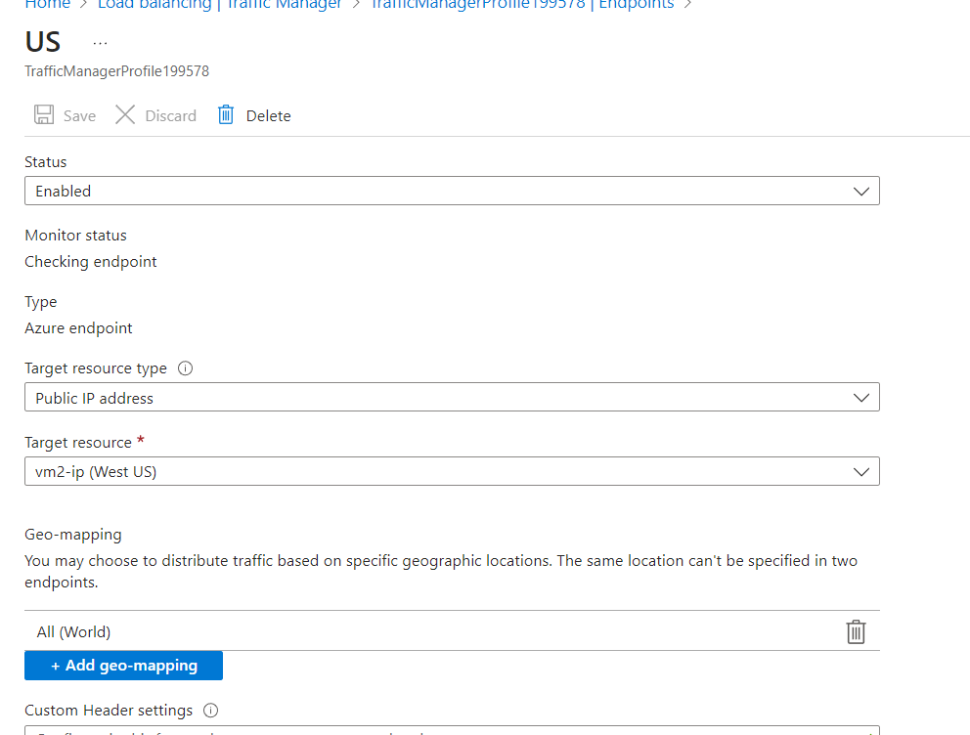

**Step 11: Test the Configuration**

1. **Obtain the Traffic Manager DNS Name**:
   * After the configuration is complete, you will get a DNS name for your Traffic Manager profile (**http://trafficmanagerprofile199578.trafficmanager.net**).
2. **Test the Traffic Manager**:
   * Open a web browser and navigate to the Traffic Manager DNS name ([**http://trafficmanagerprofile199578.trafficmanager.net**](http://trafficmanagerprofile199578.trafficmanager.net)).

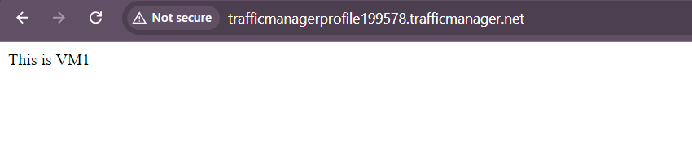

Now I changed India endpoint as North America  
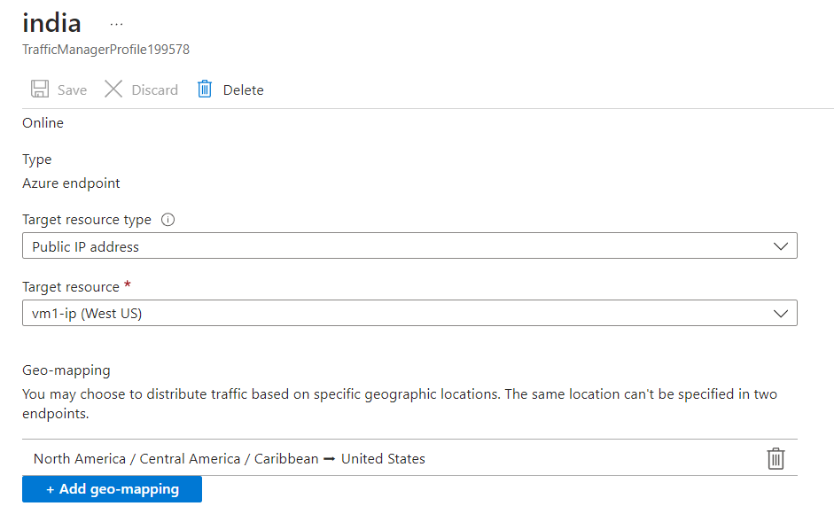  
so I am getting response from VM2 because in vm2 Geo-mapping is all world

